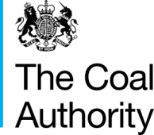

**Coalfield strategy document**

**East of Wear Coalfield**

**Dawdon and Horden Section**

August 2014

© The Coal Authority

**Version History**

|  |  |  |  |
| --- | --- | --- | --- |
| **Version** | **Date** | **Authors** | **Comments** |
| 1 |  | Lee Wyatt | Draft for comment |

**Introduction**

This document outlines the current known details, and risks associated with rising mine water in the East of Wear Coalfield (Dawdon & Horden section), northeast England. The document also summarises any key potential stakeholders, followed by options and recommendations as part of the forward strategy for preventing risks from occurring.

**Summary and History**

The East of Wear Coalfield (Dawdon & Horden section) is located on the Durham coast in the northeast of England, from Sunderland in the north to Hartlepool in the south (see figure 1). The mining extent (*c.*180 km2) covers both onshore (inland) and offshore interconnected mine workings. The majority of the Dawdon & Horden section of East of Wear coalfield is overlain by the Permian strata, itself forming an important supply of drinking water. Underground mining and associated pumping in the block ceased when Vane Tempest/Seaham and Easington Collieries closed in 1993. To the south is the South of Butterknowle Fault Coalfield, where mine water rebound is complete; to the north is the Westoe/Wearmouth Coalfield, where mine water levels are currently rising; and to the west is Lumley 6th section of the East of Wear Coalfield and the Central Durham Coalfield, where mine water levels are controlled by gravity discharges and pumping.

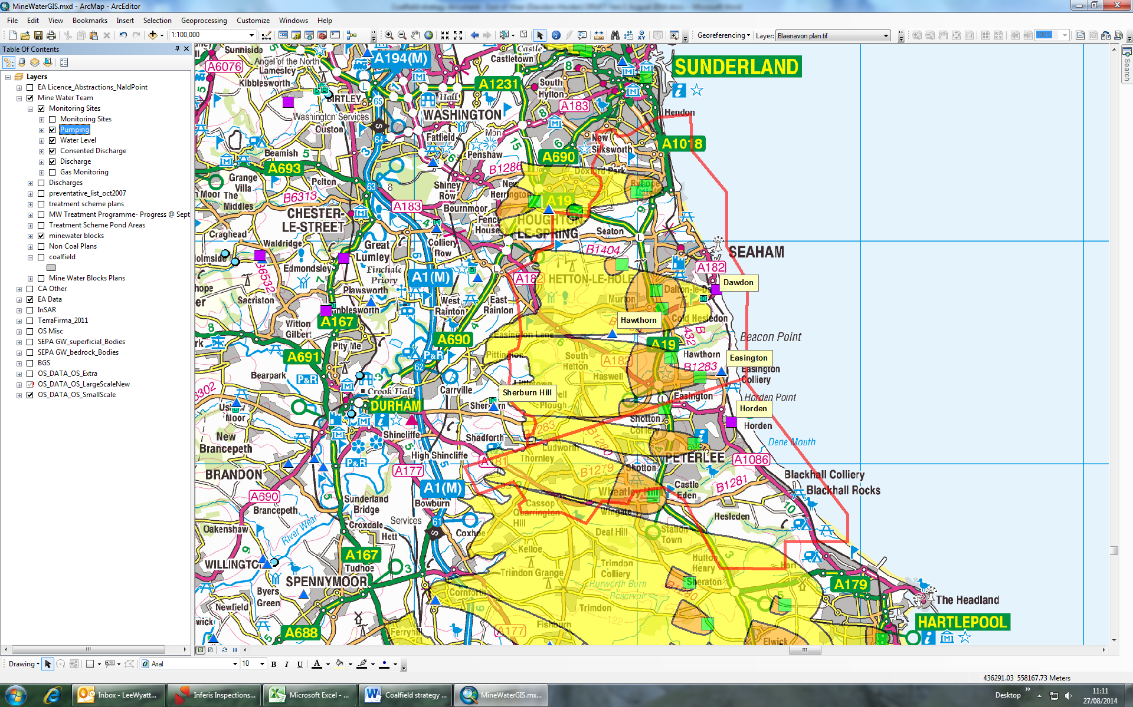

**SPZ Zone II**

**Mine water monitoring**

**Mine water pumping**

**SPZ Zone III**

**Groundwater wells**

Reproduced by permission of Ordnance Survey on behalf of HMSO. © Crown copyright and database right 2012. All rights reserved. Ordnance Survey Licence number: 100020315

**Figure 1** – Location map for Dawdon and Horden area, groundwater source protection zones and key sites

To date there have been a number of specific studies undertaken for the Coal Authority on the East of Wear Coalfield, with the last report being by WYG in 2006; although the area was covered in the UK Overview Summary Report (WYG, 2012). From these reports there are known and assumed risks from mine water rebound along with assessments of various pumping strategies. The current strategy for this coalfield is detailed below; however this report will assume the risks from insufficient pumping.

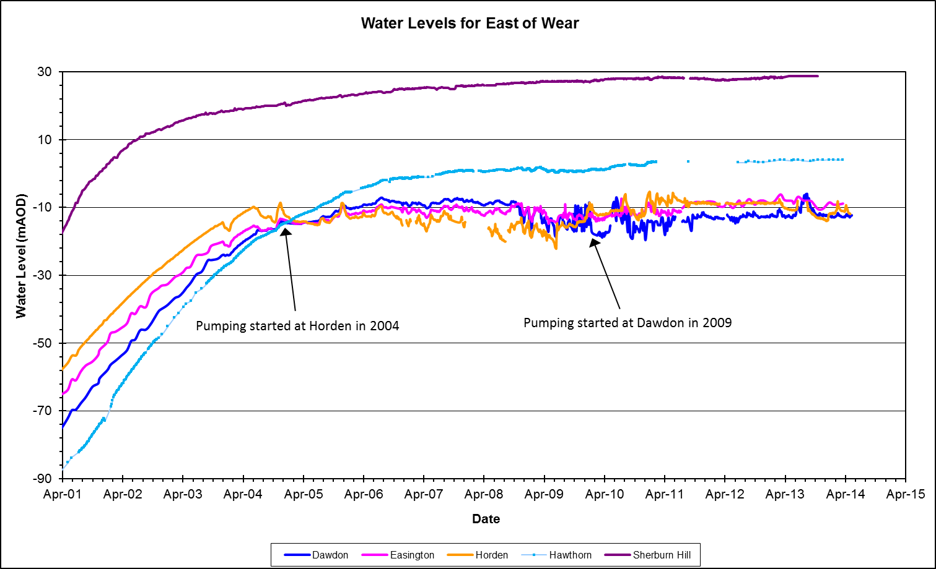

**Figure 2** – Mine water level in the East of Wear (Dawdon & Horden section) Coalfield since 2001 to 2014.

Since the closure of the collieries in 1993, the mine water levels have been monitored at various shafts across the coalfield (see figure 1 named sites). From the monitoring data, predictions were made about the rate of rise and likely timings for the water level to reach the critical level (i.e. aquifer water level). To prevent the mine water from entering the aquifer, a strategy of pumping and treating the mine water was proposed (i.e. IMC, 2001, IMC 2002a, IMC 2002b). Hence, in 2003 a short pumping test was undertaken at Horden, and in 2004 long-term pumping was implemented at Horden. The initial treatment of the mine water at Horden was via an active chemical treatment plant; designed to be a temporary measure until the next phases of the strategy were completed. Thus, in 2008 the treatment plant at Dawdon became operational, with the strategy for the majority of the total pumped water (i.e. approx. 100 L/s of the 140L/s) to be treated at Dawdon and the remaining (approx. 40L/s) to be treated at Horden. After changes to the pumping strategy (i.e. majority of flow pumped at Dawdon) there was a change in the mine water chemistry at Horden. With increases in flow at Horden above ~40 L/s, this is a decrease in the quality of the mine water; hence. Although Horden has a hydraulic capacity for 50 L/s, pumping should not exceed 40 L/s. The water chemistry at Horden was less saline with lower iron concentrations; hence plans were progressed to change the treatment methodology to a passive scheme. This became operational in 2011. The current pumping strategy and mine water control levels are detailed in the Dawdon & Horden Control Level Review (Coal Authority, 2012). However, in brief the pumping from both Dawdon & Horden should be to control the mine water level (as a mean between the two sites) at approx. 14mBOD; with Dawdon at 16mBOD and Horden at 10mBOD (CA, 2012).

**Risks**

With the existing situation of rising mine water levels and the current strategies for control of the mine water, there are a number of associated risks; the known possible risks. However, for these risks to occur, changes to the pumping strategy and / or mine water regime (i.e. flow rates, pathways) would need to alter before these risks would be realised. These risks include:

* Uncontrolled mine water discharge to drinking water aquifer: In the event that mine water levels at either Dawdon and / or Horden were to rise and not be controlled by the current pumping strategy; the mine water would likely discharge in to the overlying aquifer. The pumped mine water quality at both Dawdon and Horden is saline with elevated concentrations of chloride and sulphate (and other elements). Modelling undertaken by WYG in 2006 (WATERCHEM, 2007) indicated that approx. 4% mine water (96% aquifer groundwater) would be required to contaminate the aquifer.
* Uncontrolled mine water discharge to surface watercourses: Similarly to the risk of aquifer pollution above; if the water level was to rise at Dawdon and / or Horden, there would be a risk of mine water discharging to surface watercourses. Although specific locations of such discharges are currently unknown, the likely places would be along low-laying areas such as the Wear Valley and the Durham Coastline. Under such instances, the pollution is also likely to be visible with elevated concentrations of iron (and other elements) causing contamination.
* Insufficient mining connections and mine water control: The current pumping strategy is based on the current mining regime with connection areas of mining. The connections between these blocks vary in type and typically include open roadways, goaf connections, narrow pillars, boreholes etc. In the event that such connections became blocked or changed in the future, this could result in pumping not controlling a certain part of the coalfield; therefore in this block the water level would likely rise and lead to the risks of discharges to surface and aquifers.
* Increases in rainfall due to climate change: The pumping at Dawdon and Horden is such to control the current inflows of mine water. However, if the amount of rainfall increases in the future, there could be more flow in the mine workings; thus increased abstraction rates would be required to prevent the water level from rising. Within the current pumping regime both Dawdon and Horden have the capacity to pump more water (i.e. > 50L/s extra, c. 40% extra) than at current; although improvement to treatment systems may be required.
* Changes to environmental permits and licences: At both Dawdon and Horden the pumped mine water is treated prior to being discharged to the North Sea. These discharges are consented by the Environment Agency and are subject to review by the Agency. If alterations to the current consents were made, the required treatment method and technology, or the pumping strategy could change. This could result in additional costs of treating the mine water or result in reductions in pumping rates which could cause water levels to rise.

**Stakeholders**

Key stakeholders include:

* Environment Agency (EA) – Responsible for regulating any pollution regarding surface water and groundwater. EA’s key driver is to avoid deterioration of status of water bodies assessed under Water Framework Directive. Any future remedial scheme will require significant liaison with EA regarding the works, and licences.
* The Coal Authority Public Safety and Subsidence Department – Potential for increased enquiries and hazards.
* Local Authorities – May receive complaints from local residents and industry regarding ochreous discharges and other related issues. Any current / future schemes will also require significant amount of correspondence and planning with local authorities.
* Surface and or groundwater abstractors – Include private and public supplies, where there may be a potential to affect their wells or abstractions. Currently Northumbria Water abstract drinking water from the Permian aquifer.
* Marine Maritime Organisation – Responsible for activities along the coastline and in particular those relating to discharge structures.
* Identify potential stakeholders who may benefit from any scheme and may be willing to make a contribution.

**Options for Coalfield Mine Water Management**

The strategies shown below are long term options for mine water control. Within the coalfield there may be other potential options for long-term mine water control; these include, but not limited to the following options:

1. Current pumping strategy: This is to control the mine water by pumping and treating the majority of the water at Dawdon with up to 40 L/s being pumped and treated passively at Horden.
2. Alternative treatment methodology (both passive): The original scheme at Horden was an active treatment plant; however when Dawdon plant became operational the pumping at Horden was reduced and the chemistry of Horden water became appropriate to treat by passive systems. In the future and if the salinity of the water (or other methods are found), there could be a potential to treat Dawdon water by passive systems. This would also remove the risks relating to failure of the active plant.
3. Alternative treatment methodology (both active): After the Horden Passive scheme became operational and on occasions when Horden as pumped >40 L/s there is a deterioration in mine water quality (both salinity and iron); hence the passive scheme firstly has difficulties in removing the iron; and secondly higher salinity puts stress on to the reed bed. If there is a requirement to pump extra water at Horden, the current passive scheme may require being changed to an active scheme. Equally if active schemes result in a more cost-effective system (i.e. sludge re-use etc); an active scheme could be constructed.
4. Controlled water level rise / controlled discharge(s): Pumping at Horden and Dawdon is undertaken at the set control level to avoid contamination of the aquifer. Unless the aquifer was no longer required and / or it was proved the mine water would not pollute the aquifer (i.e. no connections or improved water quality). Such an option for a controlled rise would not be recommended. However, if such a scenario for gravity discharge could be met, the option of controlled rise and controlled discharge would be recommended.
5. Controlled discharges: This is the same as option 4 above, although would not include controlled the mine water rise. Currently as per option 4, this option is not seen to be viable
6. No pumping and / or no controlled gravity discharge: If no pumping was to take place and the water level was allowed to rise uncontrolled; the mine water would likely discharge to the aquifer groundwater and also to surface.

**Recommendations**

A. Recommendations for monitoring

Continue monitoring water levels at all the current monitoring sites, this would allow the Authority to identify and assess any future changes to the mine water regime.

Continue to sample the pumped and treated mine water from both Dawdon and Horden, this allows the Authority to assess the treatment method and efficiency and also to highlight if any future changes to treatment methodology would be beneficial or required.

B Recommendations for Scheme Development

Continue to operate both Horden and Dawdon pumping and treatment schemes. As part of this operation regular assessment should be made of the pumping strategy and the treatment options for the mine water.

Continue discussions with EA and any other stakeholder regarding the existing strategy and any future strategies.

**References**

Coal Authority 2012. Dawdon & Horden Control Level Review, August 2012. Wisdom Ref: 004418606

IMC 2001. Durham – Options for the control of mine water East of the River Wear. Prepared for the Coal Authority. Wisdom Ref: 003209158

IMC 2002a. Durham – East of the River Wear alternative mine water pumping sites. Prepared for the Coal Authority. Wisdom Ref: 003183180

IMC 2002b. Durham – East of River Wear mine water control options assuming no central mine water pumping and treatment scheme. Prepared for the Coal Authority. Wisdom Ref: 003189616

WaterChem 2007. Optimization of mine water discharge by monitoring and modelling of geochemical processes and development of measures to protect aquifers and active mining areas from mine water contamination. Research Programme of the Research Fund for Coal and Steel Coal RTD. Technical Report 7, RFC-CR-03006.

WYG 2006. Report on the options for control of mine water in the East of Wear area. Prepared for the Coal Authority. Wisdom Ref: 002091102

WYG 2012. Overview of Mine Water in the UK Coalfields, Advice on Mine Water recovery and Mine Gas. Prepared for the Coal Authority. Wisdom Ref: 002752983